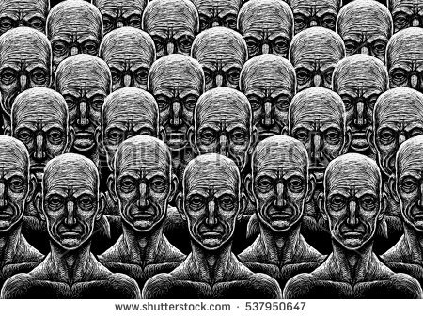**MATERIAL 3**

**What Are Utopias and Dystopias?**

The word utopia comes from the Greek words ou, meaning "no" or "not," and topos, meaning "place." Since its original conception, utopia has come to mean a place that we can only dream about, a true paradise. Dystopia, which is the direct opposite of utopia, is a term used to describe a utopian society in which things have gone wrong. Both utopias and dystopias share characteristics of science fiction and fantasy, and both are usually set in a future in which technology has been used to create perfect living conditions. However, once the setting of a utopian or dystopian novel has been established, the focus of the novel is usually not on the technology itself but rather on the psychology and emotions of the characters who live under such conditions.

Although the word utopia was coined in 1516 by Sir Thomas More when he wrote *Utopia*, writers have written about utopias for centuries, including the biblical Garden of Eden in Genesis and Plato's *Republic*, about a perfect state ruled by philosopher-kings. More's *Utopia* protested contemporary English life by describing an ideal political state in a land called Utopia, or Nowhere Land. Other early fictional utopias include various exotic communities in Jonathan Swift's famous *Gulliver's Travels* (1726).

The idea of utopias continued to be popular during the nineteenth century. For example, English author Samuel Butler wrote *Erewhon* (1872) ("nowhere" spelled backward) and *Erewhon Revisited* (1901), and William Morris wrote *News From Nowhere* (1891). In the United States, people have attempted to create real-life utopias. A few of the places where utopian communities were started include Fruitlands, Massachusetts; Harmony, Pennsylvania; Corning, Iowa; Oneida, New York; and Brook Farm, Massachusetts, founded in 1841 by American transcendentalists. Although the founders of these utopian communities had good intentions, none of the communities flourished as their creators had hoped.

**Dystopias** are a way in which authors share their concerns about society and humanity. They also serve to warn members of a society to pay attention to the society in which they live and to be aware of how things can go from bad to worse without anyone realizing what has happened.

Examples of fictional dystopias include Aldous Huxley's *Brave New World* (1932), Ray Bradbury's *Fahrenheit 451* (1953), and George Orwell's *Animal Farm* (1944) and *Nineteen Eighty-Four* (1949).

(from: <https://www.cliffsnotes.com/literature/g/the-giver/critical-essays/what-are-utopias-and-dystopias>)